Black Hawk, Colorado
August 12 – 13, 2026

8/12
Depart Pueblo at 8:00 a.m. from the Elks club. Pick up Colorado Springs passengers at 9:00 a.m. at a location to be announced.
Drive to Georgetown; free time for lunch and shopping. The bus will drive you to the Georgetown Loop Railroad for your train excursion. After the train ride the bus will take you to your hotel in Black Hawk. The rest of the evening is free.

8/13
We’ll depart Black Hawk this morning after breakfast and head to Manitou Springs for shopping and lunch on your own. Mid-afternoon we depart this beautiful little Colorado town. Colorado Springs passengers will be dropped at the pick-up point and Pueblo passengers will arrive in Pueblo at 4:00 p.m.

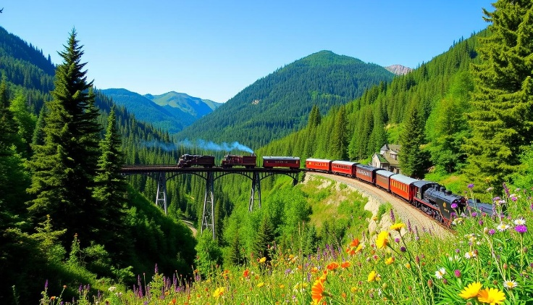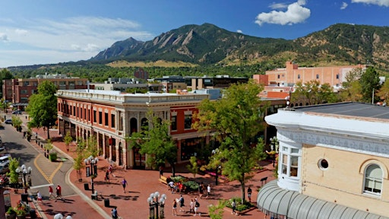

Total price - $345 per person, double occupancy. Single supplement is $85. Full payment is due by June 1 and is non-refundable. If you need to cancel you are welcome to find a replacement.

For information or to make a reservation, please contact:
Kris Monroe
Quality Cruises and Travel
719-685-0544
qualitycruisesandtravel@yahoo.com

